**JOINT SAVINGS ACCOUNT IN SOLIDITY + TRANSACTIONS**

**DEPOSITING OF 10 WEI**

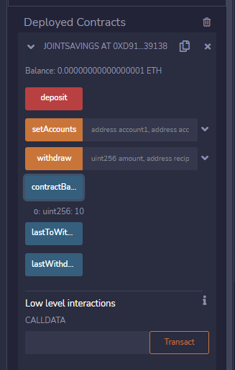



**DEPOSITING OF 1 WEI**

**DEPOSIT OF 5 ETHER**

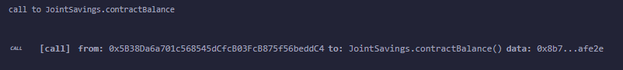

**Withdrawal of 2 Wei**

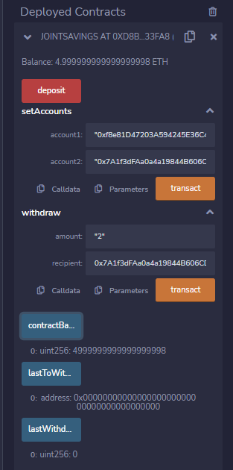

**WITHDRAWAL #2**

